Android based Blood Bank Network System
Software Requirements Specification

Version 1.0



Group Id: F170233080
Supervisor Name : Asim Mehmood

Revision History
Date (dd/mm/yyyy) | Version | Description | Author
24/11/2017 | 1.0 | A Software Requirement Specification is a document that captures complete description about how system will work.  It lays out Functional and non Functional requirements, it also include set of use-cases  that describe user interactions that software must provide. It also include usage scenario and adopted methodology.  SRS should be complete, consistent, verifiable, unambiguous and correct.

Table of Contents

- Scope (of the project)
- Functional Requirements Non Functional requirements
- Use Case Diagram
- Usage Scenarios
- Adopted Methodology
- Work Plan (Use MS Project to create Schedule/Work Plan)

SRS Document

Scope of Project:

The Android project mainly used in emergency situations, through mobile user can get whole information regarding blood donors. This project acts as a significant role in saving life of human beings and which is also its main aim. The project Android Blood Bank network system is developed so that users can view the information about registered blood donors such as name, address, and other such personal information along with their details of blood group and other medical information of donor.
Thus this application helps to select the right donor online instantly using medical details along with the blood group.
The main aim of developing this application is to reduce the time to a great extent that is spent in searching for the right donor and the availability of blood require.. Thus this application provides the required information in no time and also helps in quicker decision making.

Android Blood Bank is mobile based project. Mobile is a portable device, so far it can move easily from one place to another place. So mobile is the best choice for communication. By using of this application people who want to donate their blood can register in this application by providing their details. And persons who needs blood then they can search and found the blood which group they need. After searching, the list of donors will be displayed. Then user can communicate with them easily.

Functional and non Functional Requirements:

Functional Requirements:

1: Register the user
2: Login of user
3: Register the donor by himself
4: Insert personal and medical information plus the blood group by the donor
5: User can view all the donor details
6: Select the required donor
7: Send the request to the selected donor
8: The donor should be able to respond the request
9: The requester can contact donor

Non Functional Requirements:

- Performance: Application should be designed and developed in such a way that it should not utilize too many resources.

- Usability: Usability defines how well the application meets the requirements of the user and consumer by being intuitive, easy to localize and globalize, providing good access for disabled users, and resulting in a good overall user experience.
- Secure: login system should be safe and secure.

Use Case Diagram(s):
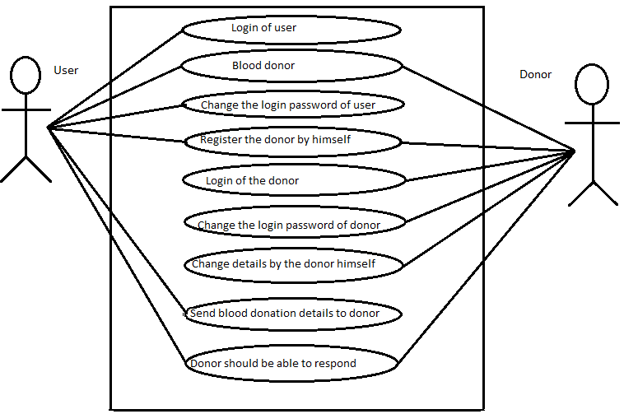
Usage Scenarios:

Usage Scenario 1:
 | Use case related to registration of user
Use case title |  | Register user
Abbreviated title |  | Reg_user
Use case ID |  | ABBN_FR_1
Actors |  | User
Description |  | This use case enable user to register himself.
Pre conditions |  | Internet connection should be available.
Task sequence |  |  |  | Exceptions
- User initiates the command to starts the application  - System is shown the all features  - User initiates the register of user command  - A small questionnaire given to the user, which is related to personal & contact details.  - The user answers the questionnaire and finishes the registration.  - Alert the user by sending e-mails & SMS messages about the registration |  |  |  | 1. User has entered the invalid mobile phone number.
Post  condition |  |  | User has registered successfully.
Author |  |  | Mc160401662

Usage Scenario 2:
 | Use case related to registration of donor
Use case title |  | Register donor
Abbreviated title |  | Reg_donor
Use case ID |  | ABBN_FR_1
Actors |  | Donor
Description |  | This use case enable donor to register himself.
Pre conditions |  | Internet connection should be available.
Task sequence |  |  |  | Exceptions
- Donor initiates the command to starts the application.  - System is shown the all features.  - Donor initiates the register of a donor command.  - A small questionnaire given to the donor, which is related to personal & contact details.  - The donor answers the questionnaire & goes to the next step.  - The system asks the donor to submit the health condition report & the evidence report of blood group.  - The donor submits the reports & finishes the registration.  - Alert the donor by sending e-mails & SMS messages about the registration . |  |  |  | - Donor has entered the invalid mobile phone number.  - Donor doesn’t submit the required reports.
Post  condition |  |  | Donor has registered successfully.
Author |  |  | Mc160401662

Usage Scenario 3:
 | Use case related to login of user
Use case title |  | Login user
Abbreviated title |  | Login_user
Use case ID |  | ABBN_FR_1
Actors |  | User
Description |  | This use case enables the user to login.
Pre conditions |  | Internet connection should be available.
Task sequence |  |  |  | Exceptions
- User initiates the command to starts the application  - System is shown the all features  - Click the ‘Login of user’ command button.  - The system asking for the user name & the password.  - User provides the user name & the password. |  |  |  | - The provided password is wrong.  - Allow the user to re-enter the password.
Post  condition |  |  | User has logged in successfully.
Author |  |  | Mc160401662

Usage Scenario 4:
 | Use case related to change the password of user
Use case title |  | Change the password
Abbreviated title |  | password_user
Use case ID |  | ABBN_FR_1
Actors |  | User
Description |  | This use case enables the user to change his password.
Pre conditions |  | Internet connection should be available. User logged in.
Task sequence |  |  |  | Exceptions
- User selects the command to change the password.  - The system is asked to type the current password, new password & again the new password to confirm it.  - User provides the current password, new password & confirm new password.  - New password is stored in the system. |  |  |  | - Current password is wrong.  - New password doesn’t match with the current new password.
Post  condition |  |  | User has changed the password successfully.
Author |  |  | Mc160401662

Usage Scenario 5:
 | Use case related to login of donor
Use case title |  | Login donor
Abbreviated title |  | Login_donor
Use case ID |  | ABBN_FR_1
Actors |  | Donor
Description |  | This use case enables the donor to login.
Pre conditions |  | Internet connection should be available.
Task sequence |  |  |  | Exceptions
1. Donor initiates the command to starts the application.  2. System is shown the all features.  3. Click the ‘Login of donor’ command button.  4. The system asking for the user name & the password.  5. Donor provides the user name & the password. |  |  |  | 1: The provided password is wrong.
Post  condition |  |  | Donor has logged in successfully.
Author |  |  | Mc160401662

Usage Scenario 6:
 | Use case related to select donor
Use case title |  | Select the donor
Abbreviated title |  | Select_Donor
Use case ID |  | ABBN_FR_1
Actors |  | User
Description |  | This use case enables the user to select the donor.
Pre conditions |  | Internet connection should be available. User logged in.
Task sequence |  |  |  | Exceptions
- User will search the donor.  - User reads information of the donor.  - User selects the donor.  - User sends request.  - Click on close button. |  |  |  | 1. If donor contact information is wrong request will not be made.
Post  condition |  |  | User has successfully selected donor.
Author |  |  | Mc160401662

Usage Scenario 7:
 | Use case related to send request
Use case title |  | Send request to the donor
Abbreviated title |  | Req_Send
Use case ID |  | ABBN_FR_1
Actors |  | User
Description |  | This use case enables the user to send request.
Pre conditions |  | Internet connection should be available. User logged in.
Task sequence |  |  |  | Exceptions
- User selects the command to search donors for exact blood group.  - System asks to insert the blood group.  - User inserts the needed blood group details.  - Select donors for the donation.  - Donors who are willing to attend to the donation will reply to the system. |  |  |  | 1. There is no donor in the system who can donate blood to that blood group.
Post  condition |  |  | User has successfully sent the request.
Author |  |  | Mc160401662

Software Development Methodologies

Software development methodologies are also known as system development methodologies. Actually this is system development life cycle, or it can be called System Development Process. Software development methodologies are frames that are used to structure, control and plan the process of developing system.

There are several models for such processes each describing approach to different variety of tasks, or activities that take place during the process. The names of the some of the methodologies are as follows:

- Agile software Development
- Incremental model
- Crystal Methods
- Extreme programming
- Waterfall model
- Spiral model

My adopted methodology is combination of these two given methodologies as follows:

Waterfall methodology
The first published model of the software development process was derived from other engineering processes. Because of the cascade from one phase to another, this model is known as the waterfall model. This model is also known as linear sequential model.
The waterfall model is a documentation-driven model. It therefore generates complete and comprehensive documentation and hence makes the maintenance task much easier. I t however suffers from facts that the client feedback is received when the product is finally delivered and hence any errors in the requirement specifications are not discovered until the product is sent to the client after completion. This therefore has major time and cost related consequences.
Spiral Methodology

This model was developed by Barry Boehm. The main idea of this model is to avert risk as there is always an element of risk in development of software. For example key personnel may resign at a critical juncture, the manufacturer of the software development may go bankrupt, etc.
In its simplified form, the Spiral model is Waterfall model plus risk analysis. In this case each stage is preceded by identification of alternatives and risk analysis and is then followed by evaluation and planning for the next phase. If risks cannot be resolved, project immediately terminated.
The main strength of the Spiral Model comes from the fact that it is very sensitive to the risk. Because of the spiral nature of development it is easy to judge how much to test and there is no distinction between development and maintenance.
Each phase in Spiral model start with a design goal and end with a client reviewing the process.

Adopted Methodology
Requirements
Planning
Software requirement
Work plan
Analysis
Risk analysis
Cost effectiveness
With less risk
Deliver project with specific requirement otherwise recycle for further evaluation
Designing coding
Testing

Design
Coding
Testing
Acceptance
Client evaluation
Development
In VU model
Each phase report back

The above is VU process model which is combination of waterfall and spiral models. It has five phases first one is learning and analyzing requirements secondly making of SRS third Test phase 1 fourthly Test Phase 2 and at the end Final deliverable .In the requirement phase system goals services and constraints are established after discussion with users.

Benefits of using this methodology.
- This is sequenced model
- This model is easy to understand and use
- Each phase has specific deliverable
- In this model phases are completed and processed one at a time.
- Avoidance of risk is enhanced.
- Additional functionality can be added later.

why we use this methodology?
- This model is used when cost and risk evaluation is important.
- This methodology is also used when users are unsure of their requirement.
- It is also used when significant changes are expected.

Work Plan (Use MS Project to create Schedule/Work Plan)
<Provide Gantt chart of your final project>

